Fast Neuroevolution for Flappy Bird:
A Headless Simulator and PRML‑Style Analysis of a Simple Neuron Policy

Name: Angel Mencia
COGS 118B
Virginia De Sa
Date: December 12, 2025

Abstract
I trained an AI to play Flappy Bird using a fast “headless” evolution loop. At first, I used a Pygame version for visuals, but it was slow for big experiments because the simulation speed was tied to rendering. So I made fast_train_plus: it keeps the same basic physics/collisions, but removes drawing and adds logging so I can actually run hundreds of generations and make clean graphs. The controller is intentionally simple: it takes a few normalized “vision” inputs about the next pipe (2–3 distance features) plus a bias input fixed at 1, computes a weighted sum, and flaps when the output crosses a threshold. I evaluate learning using learning curves (fitness vs generation), fixed-seed evaluation for reproducibility, and population-level statistics.^{[2][1][7]}

(NEAT inspiration: add-connection / add-node diagram)
Source to screenshot: Stanley & Miikkulainen (2002) NEAT paper PDF
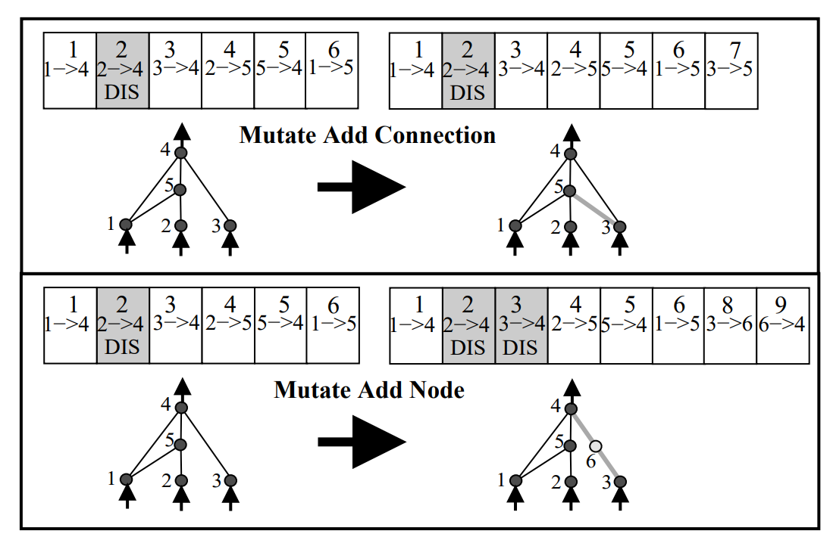
Figure 1. NEAT-style mutation idea (used as inspiration, not fully implemented). [1]

1. Introduction
Flappy Bird looks simple, but it’s a surprisingly unforgiving control problem: at every moment the agent decides “flap or don’t flap,” and a small timing error can immediately end the run. I used it as a testbed because the rules are easy to define, yet performance still shows a clear learning curve over training.

The Project was a standard Pygame game loop since it’s great for visualization and demos. The downside is that it’s not ideal for experiments. When the goal is something like 200 generations × 20 birds × thousands of steps, rendering quickly becomes the bottleneck and it’s harder to collect clean logs.

This is where the project became more than “just Flappy Bird.” I was inspired by the main idea behind NEAT-style neuroevolution: instead of training with gradients, you can improve a population of policies through selection, inheritance, and mutation. Rather than using a full NEAT library, I implemented a simpler evolution loop from scratch and built a headless trainer (fast_train_plus) that keeps the same physics and collision logic but removes drawing. This made it practical to run fast trials, repeat runs with fixed seeds, and produce PRML-style plots that show learning and stability.

1.1 The “simple neuron” controller (what a bird actually does)
Each bird’s brain is basically one small neuron (perceptron-style). It gets a small vision vector about the next pipe and a bias input. Then it does a weighted sum and runs an activation. If the output is bigger than a threshold, the bird flaps. So you can think of “flap” like the neuron firing.^{[3][4][8]}
Conceptual decision rule:
a = w1·x1 + w2·x2 + w3·x3 + w_bias·1 and if output(a) > τ → flap
(perceptron / artificial neuron with bias x0=1)
Towards Data Science article (link in References)
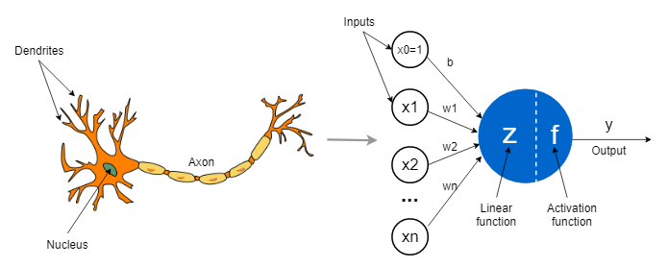

Figure 2. Perceptron-style neuron with bias input (matches “vision + bias → threshold flap” setup). [8]

2. Motivation and related work
This project started because I saw that neuroevolution can work surprisingly well for games. I used Max Rohowsky’s open-source project as a starting inspiration for structure and ideas, but I wanted to understand what was happening and make my own fast training + analysis pipeline.^{[7]}
My goal wasn’t to perfectly re-create full NEAT. Instead, I tried to keep the policy small and understandable, then focus on what PRML emphasizes: repeatable experiments, clean plots, and actually measuring behavior over time.^{[2]}

3. Methods

3.1 fast_train_plus: headless training loop
fast_train_plus runs the same basic Flappy Bird physics and collisions, but without any rendering. Each generation does: (1) simulate every bird to get a fitness score, (2) select the better birds, (3) make a new population by cloning + mutating weights, and (4) log everything to disk.
Run configuration used for the main results in this paper:
python fast_train_plus.py --seed 0 --gens 200 --pop 20 --max_steps 4000 --logdir runs/trial_seed0 --save_pop_every 1 --save_policy_every 1 --eval_every 1 --eval_seeds 0,1,2,3,4

3.2 What the key command-line args control
• --seed: makes the whole run repeatable (same random sequence).
• --gens: number of generations (how many evolutionary updates).
• --pop: number of birds per generation.
• --max_steps: maximum steps per episode. With fitness = steps survived, this also caps the max fitness.
• --logdir: where logs and checkpoints get saved.
• --save_pop_every / --save_policy_every: how often to save snapshots.
• --eval_every and --eval_seeds: evaluate the best bird on fixed seeds (helps show generalization).

The main training loop. Each generation we simulate the whole population, calculate best/average fitness, optionally run a fixed-seed evaluation, save snapshots, and print the learning progress (gen=… best=… avg=…).

3.3 Core code screenshots (4 total)
File: fast_train_plus.py
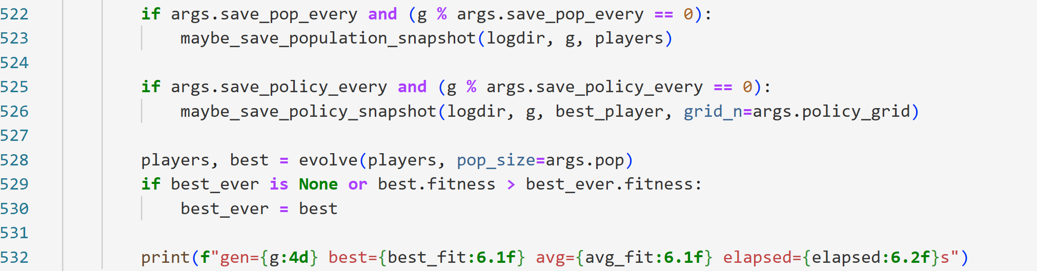
Why: this is the “learning over generations” part

The generation loop that evaluates the population and logs best/avg fitness.
File: fast_train_plus.py
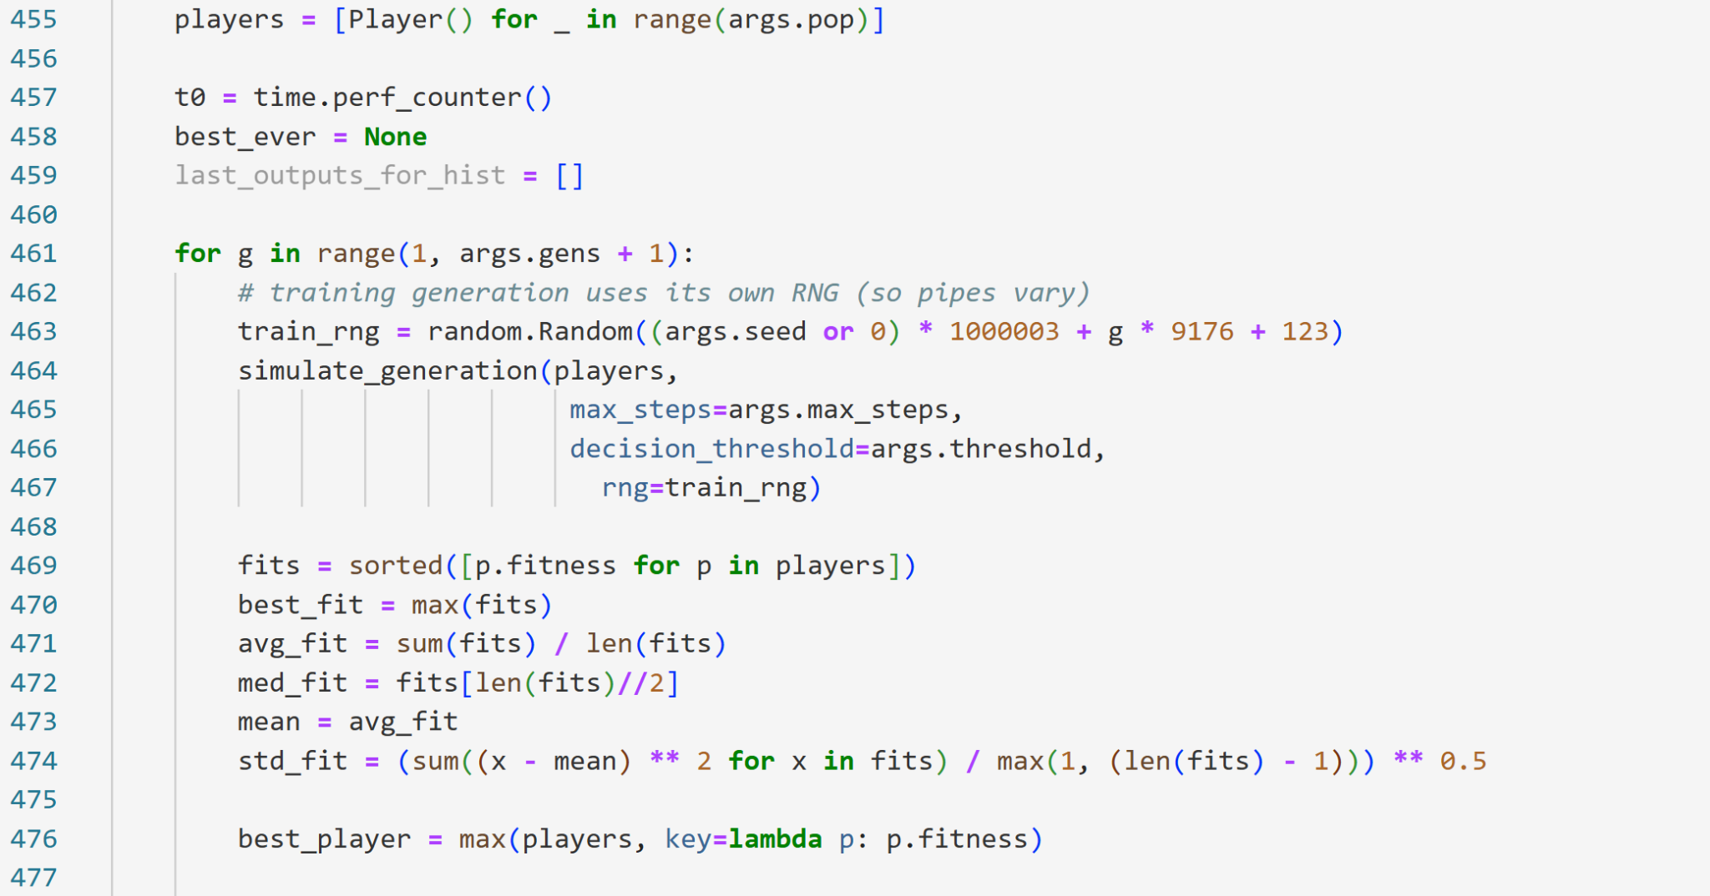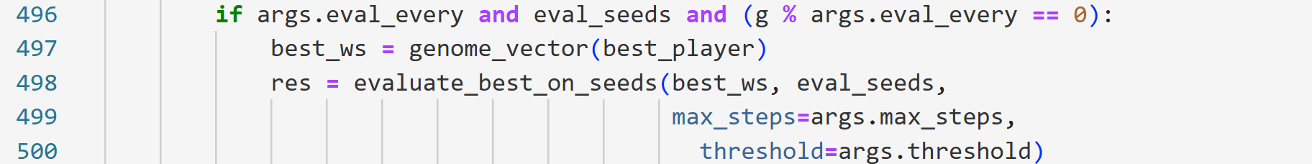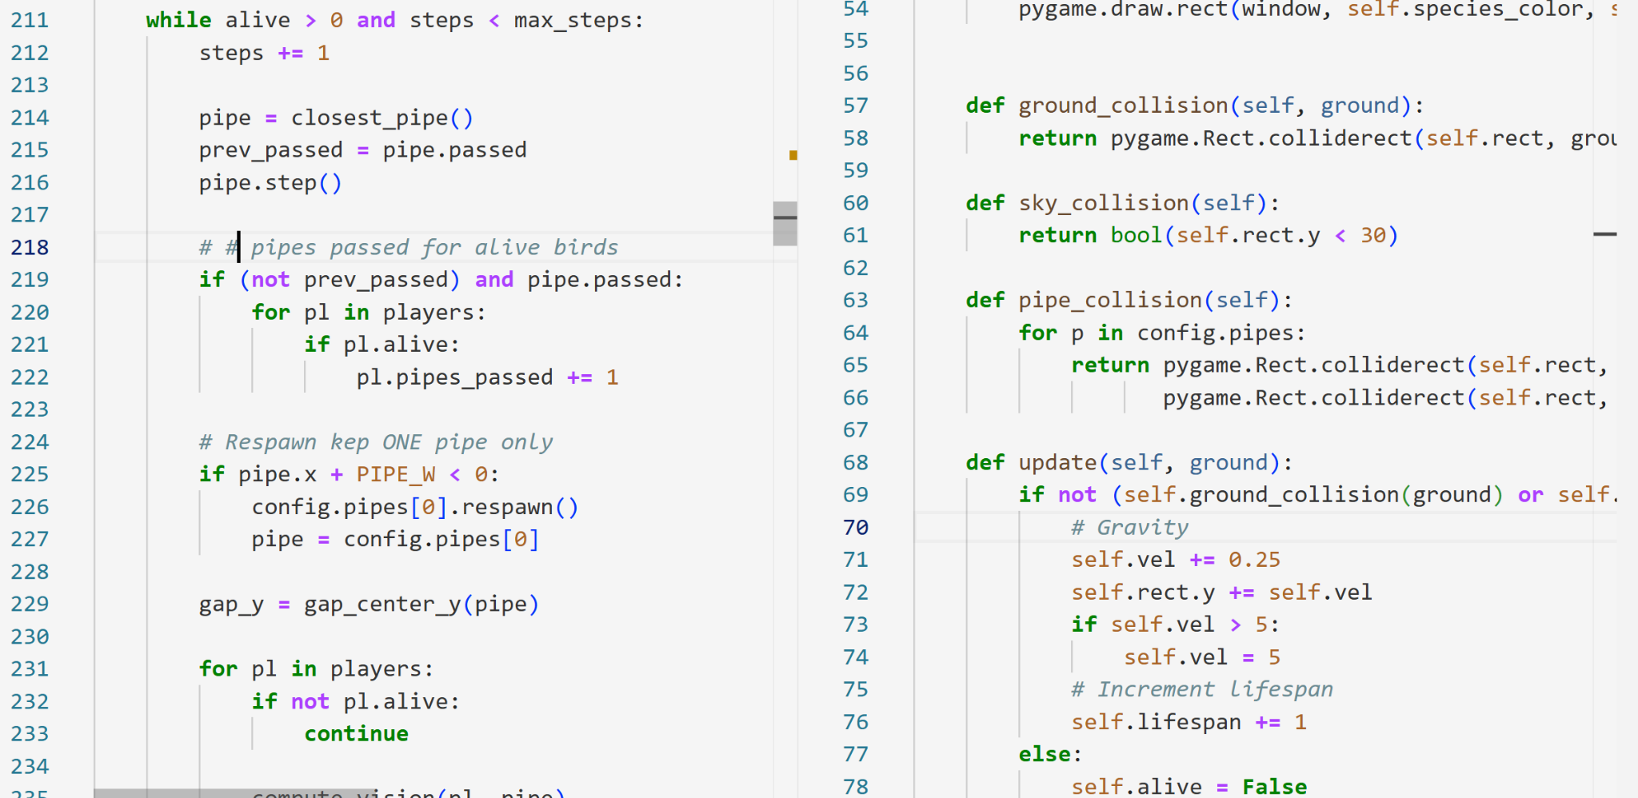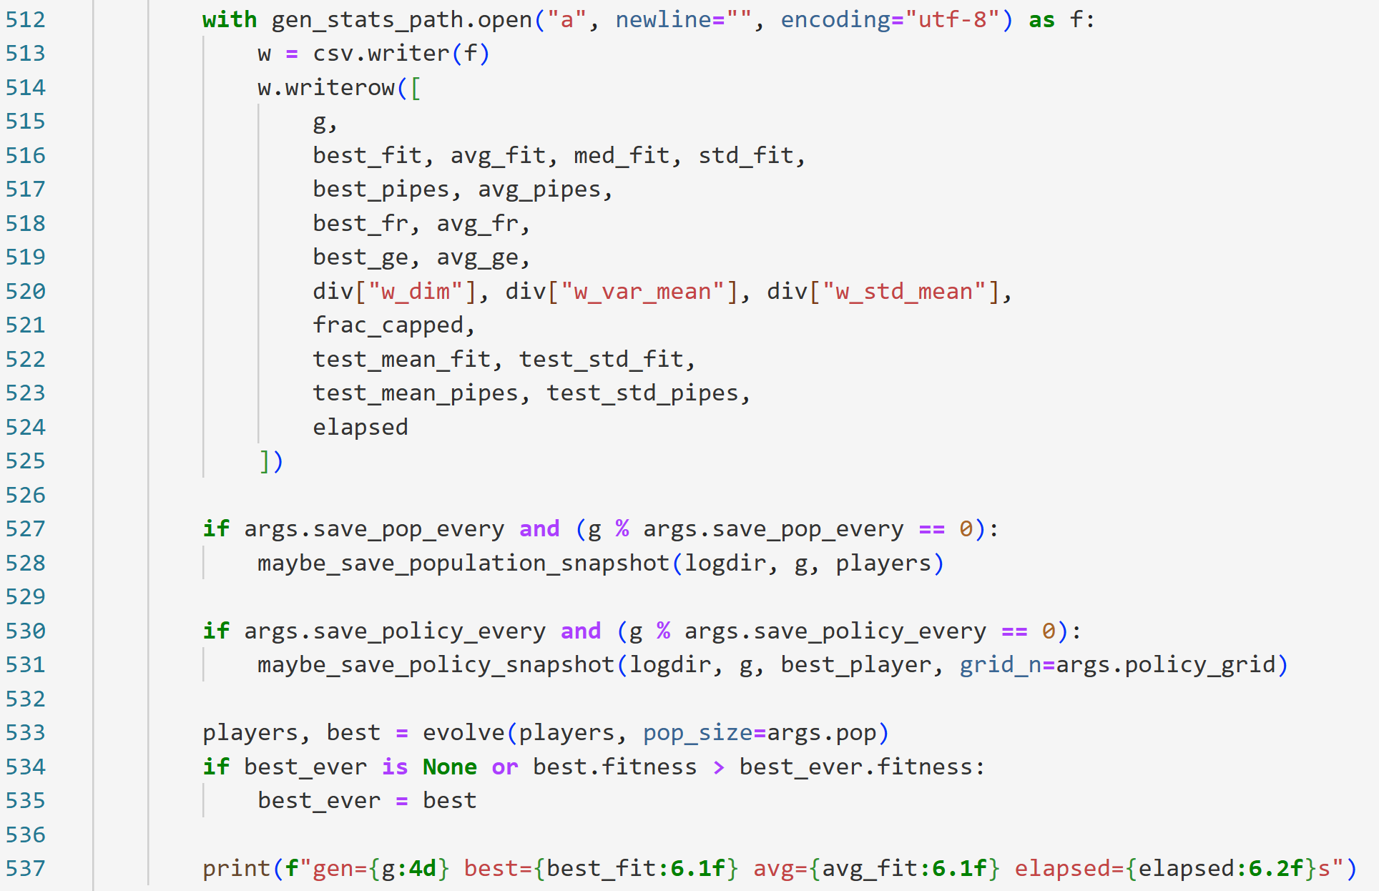
Why: proves the simulator is headless + fast

The headless simulation loop: physics, pipes, collisions, and fitness.
The headless simulator step loop. This is where the run is actually “played”: pipes move, the bird’s vision is updated, decisions are made, and then physics + collisions are applied through the player update (gravity, velocity, position, and death on collision).
File: fast_train_plus.py OR brain.py
Capture: vision inputs + bias + weighted sum + threshold flap

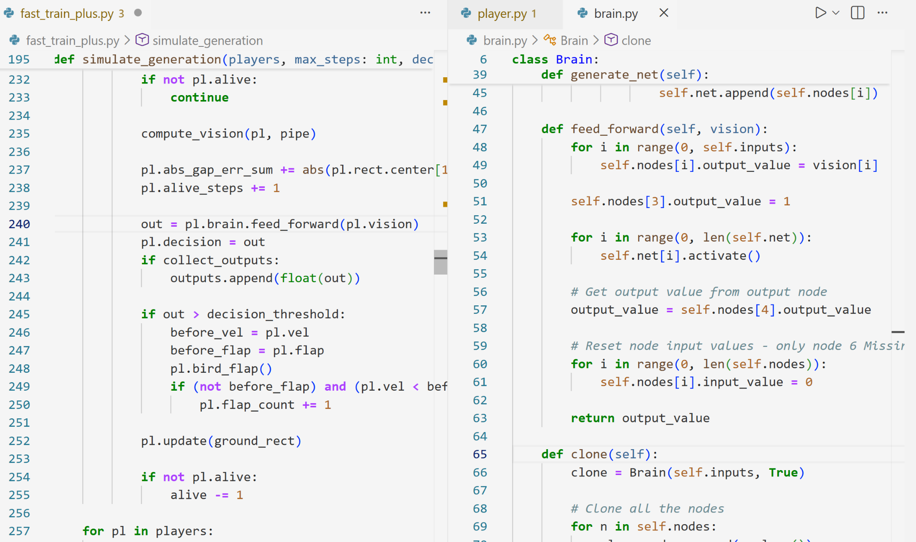
Why: connects directly to Figure 2 (perceptron)

The perceptron-like policy: vision + bias → output → flap threshold.
The “simple neuron” decision. We feed the bird’s vision inputs plus a bias input fixed at 1 into a forward pass, and if the output crosses a threshold, the bird flaps — basically like a neuron “firing.”
File: fast_train_plus.py
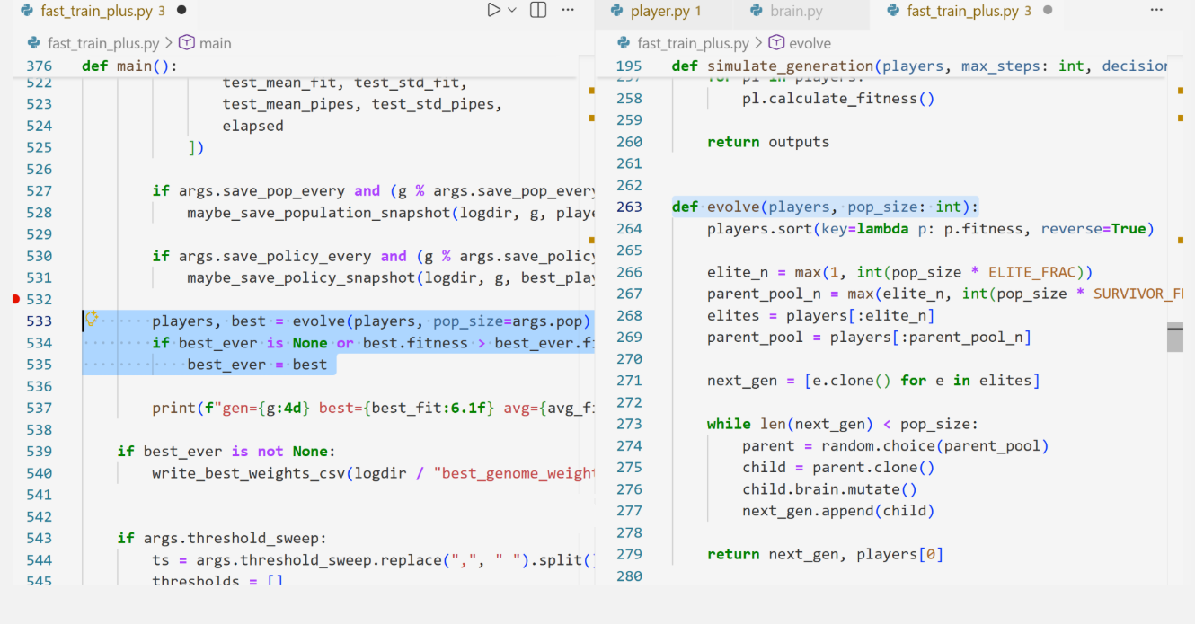
Why: this is the “evolution step” that makes the next generation

Selection + mutation that creates the next generation
The evolution update. After each generation, we build the next population by keeping the best birds (elite/selection), cloning them, and mutating their weights to create new birds for the next generation..

4. Results
For the run with seed 0, performance jumped pretty quickly and hit the ceiling at max_steps = 4000 around generation ~50. After that, the best bird kept getting 4000, which basically means “it survived the whole episode every time” under this cap.
I plot the results in two ways: (1) a full learning curve to show the big picture, and (2) zoomed-in curves (first 30–60 generations) to show the actual “breakthrough moment” where a bird first discovers a stable strategy.

(Learning curve: generations 1–200)
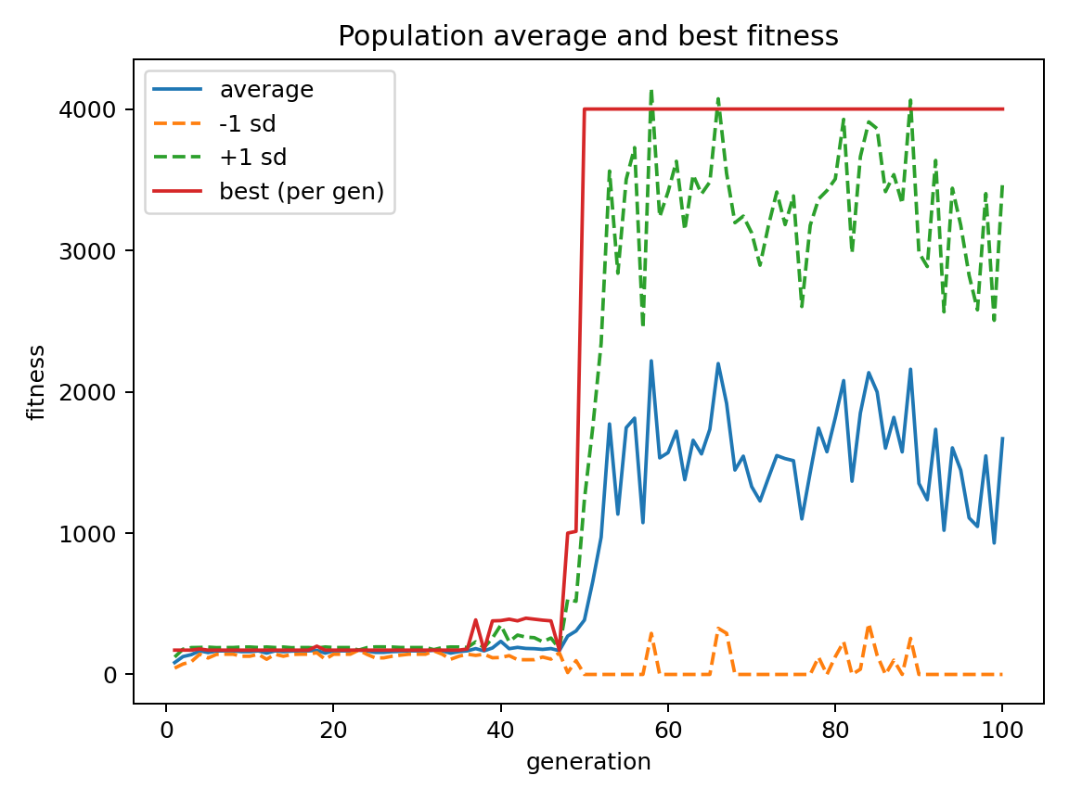
This plot reflects the same high-level behavior you see in NEAT-style neuroevolution: a population explores many policies, selection preserves strong individuals, and mutation introduces variation. The “best-per-generation” curve can improve rapidly once a good controller is discovered, while the population average remains noisy because most offspring are mutated variants that may perform worse. The wide ±1 standard deviation band shows persistent diversity in the population, which NEAT explicitly manages through speciation; in my simplified version, diversity appears naturally from mutation and the fact that not all individuals are elite.

Figure 3. Learning curve over generations (big picture).
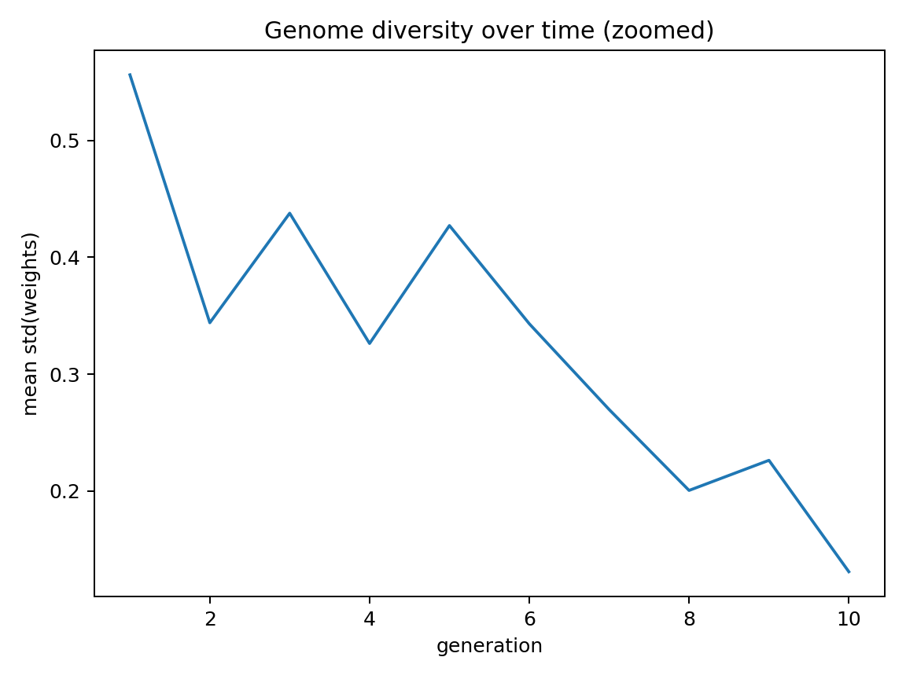
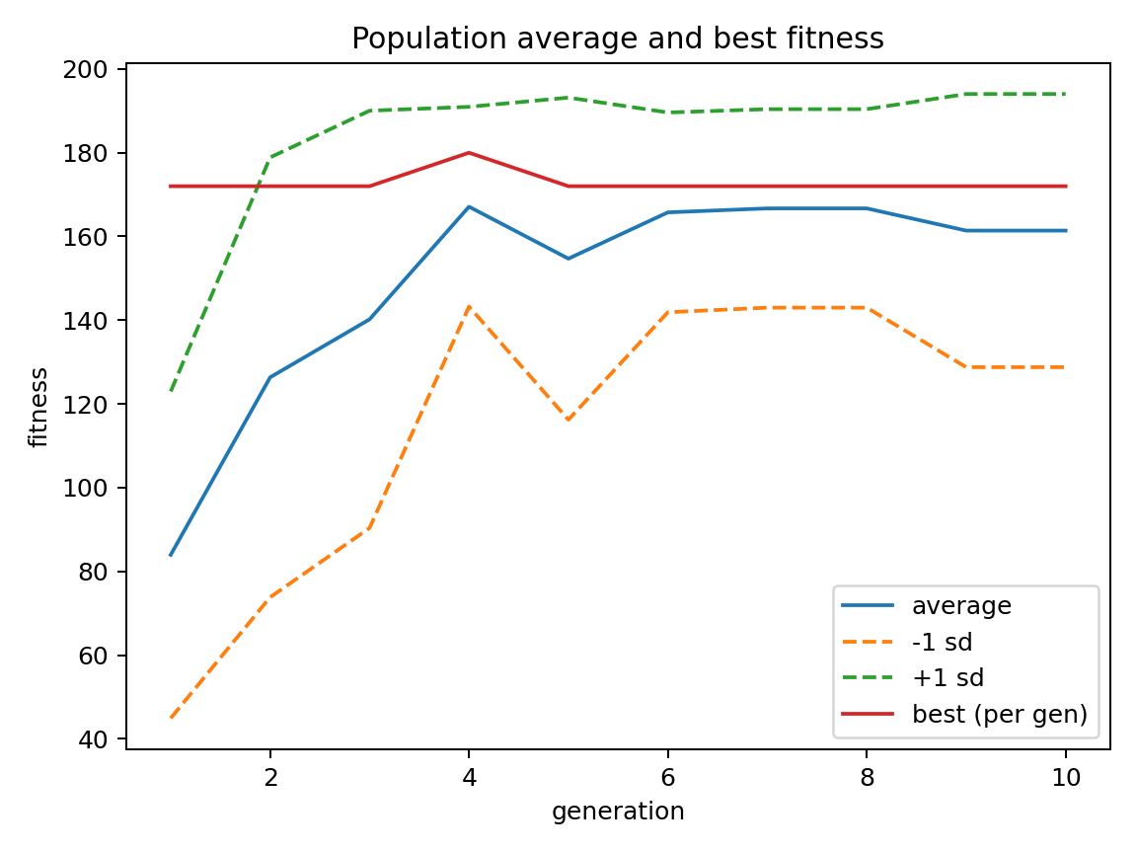
(Zoomed learning curve: generations 1–30 or 1–60)
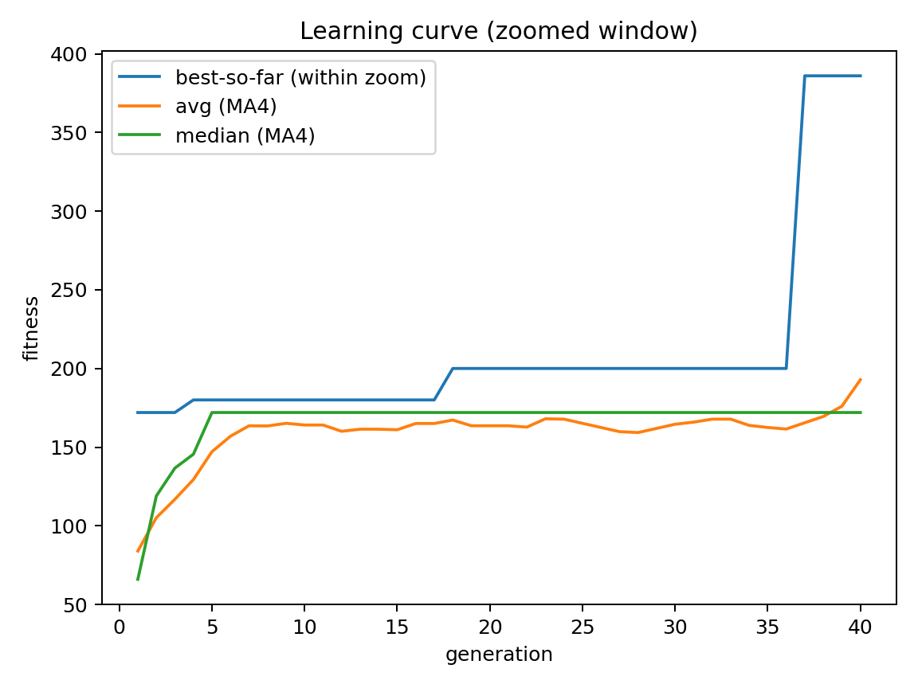
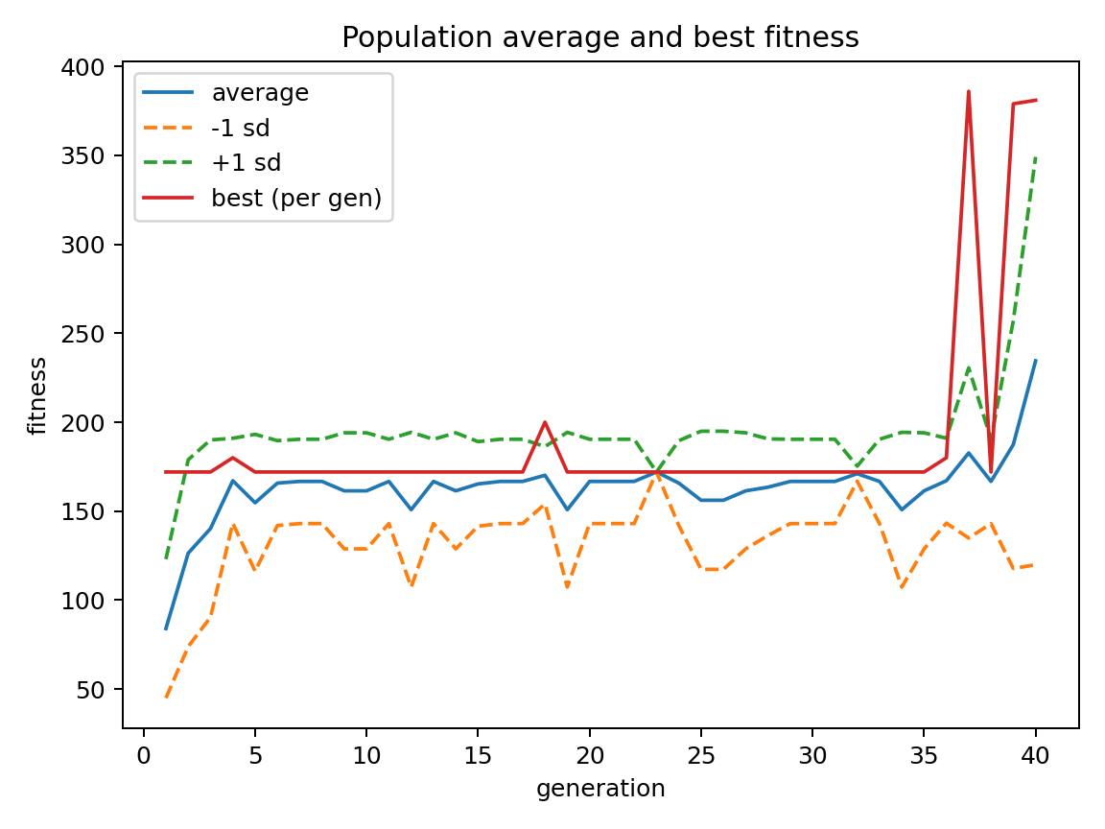
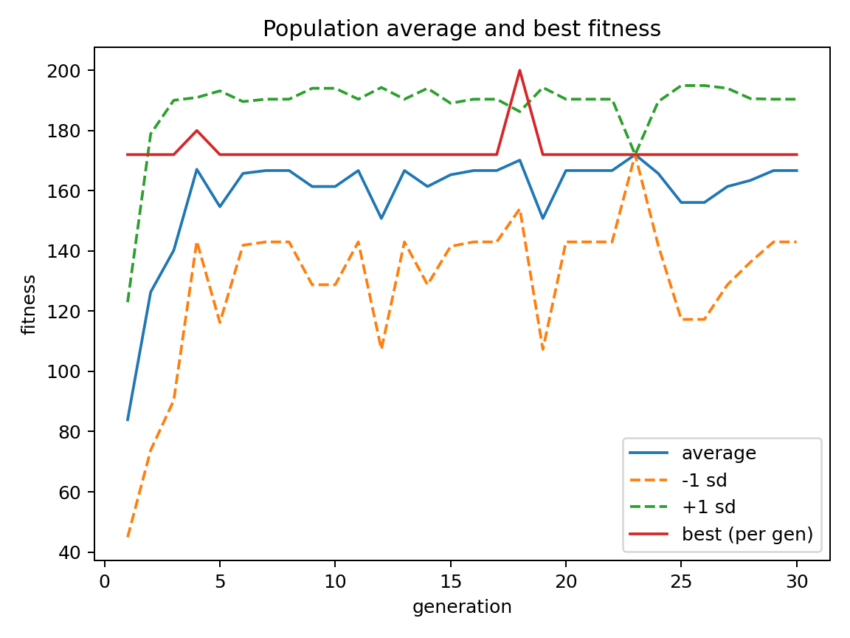
Goal: show the first time best fitness hits 4000 around gen ~50

Figure 4. Zoomed learning curve (shows the breakthrough).
(Fixed-seed evaluation: eval_seeds 0–4)
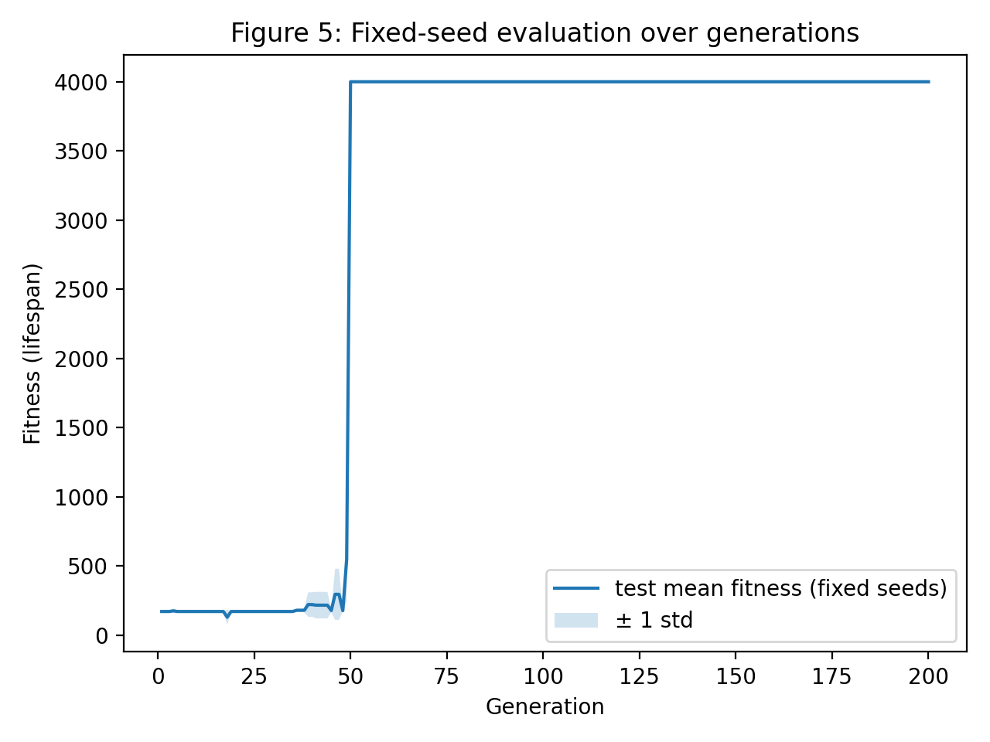
Plot: best policy evaluated on fixed seeds across gens
Goal: show stability/generalization, not just one lucky environment

Figure 5. Fixed-seed evaluation curve across training (generalization check).

5. Discussion
The biggest win in this project was speed. Once the simulator was headless, I could run lots of generations quickly and log everything in a consistent way. That made it much easier to do the kind of analysis emphasized in PRML—repeatable trials, learning curves, and comparisons across random seeds—instead of relying on a single demo run.

One thing I had to be careful about is what “convergence” really means in this setup. Because fitness is capped by max_steps, hitting a score of 4000 does not prove the policy is perfect in general—it only shows it can survive for the full time limit I allowed. Increasing max_steps makes the evaluation stricter and can reveal whether a policy is truly stable or just good enough to pass the current horizon.

If I had more time, the first extension would be improving the input features. For example, adding the bird’s vertical velocity, the center of the upcoming gap, or a more direct “error-to-gap-center” feature would likely make learning more reliable and reduce randomness. The second extension would be stronger generalization testing: evaluating on more seeds, widening the range of pipe gaps/spacings, or training on one distribution and testing on a slightly different one to see how well the controller transfers.

References
1. Stanley, K. O., & Miikkulainen, R. (2002). Evolving Neural Networks through Augmenting Topologies. Evolutionary Computation, 10(2), 99–127. https://nn.cs.utexas.edu/downloads/papers/stanley.ec02.pdf
2. Bishop, C. M. (2006). Pattern Recognition and Machine Learning. Springer.
3. Perceptron (Wikipedia). https://en.wikipedia.org/wiki/Perceptron
4. Artificial neuron (Wikipedia). https://en.wikipedia.org/wiki/Artificial_neuron
5. scikit-learn example: Plotting learning curves. https://scikit-learn.org/stable/auto_examples/model_selection/plot_learning_curve.html
6. Nielsen, M. (2015). Neural Networks and Deep Learning, Chapter 1. https://neuralnetworksanddeeplearning.com/chap1.html
7. Rohowsky, M. neft-flappy-bird (GitHub). https://github.com/maxrohowsky/neft-flappy-bird?tab=readme-ov-file#libraries
8. Towards Data Science. The concept of artificial neurons (perceptrons) in neural networks. https://towardsdatascience.com/the-concept-of-artificial-neurons-perceptrons-in-neural-networks-fab22249cbfc/

